- State the method of irrigation that will be best for dry regions such as desert. Give reason. (2)
- Study the graph given below depicting the effect of fertiliser application on crop yields in a field and answer the questions that follow : (4)
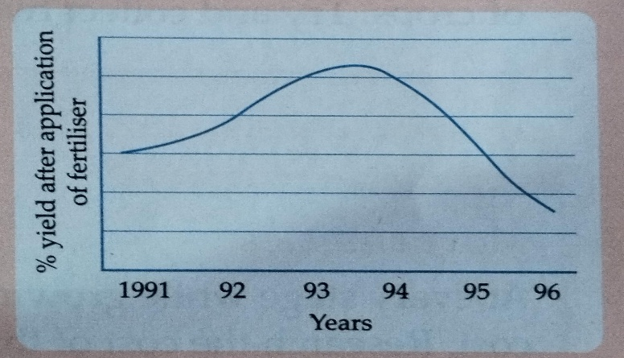
    - State the effect of fertiliser application on the crop yield?
    - The crop yield has declined in the later years. Give reason.
    - Can you suggest any alternative method to increase crop yield?
    - Mention few sustainable agricultural practices .
- Explain how pisciculture is different from apiculture. (2)
- Suggest two natural method to control pests. (2)
- Manure is slowly absorbed by plants. Give reason. (2)

